How to use the Personalized Email Automator:

This is an application which runs in a google sheet that can send mass emails which are all

personalized and unique to each recipient based on variable values in a google sheet.

Steps to using this program:

1. 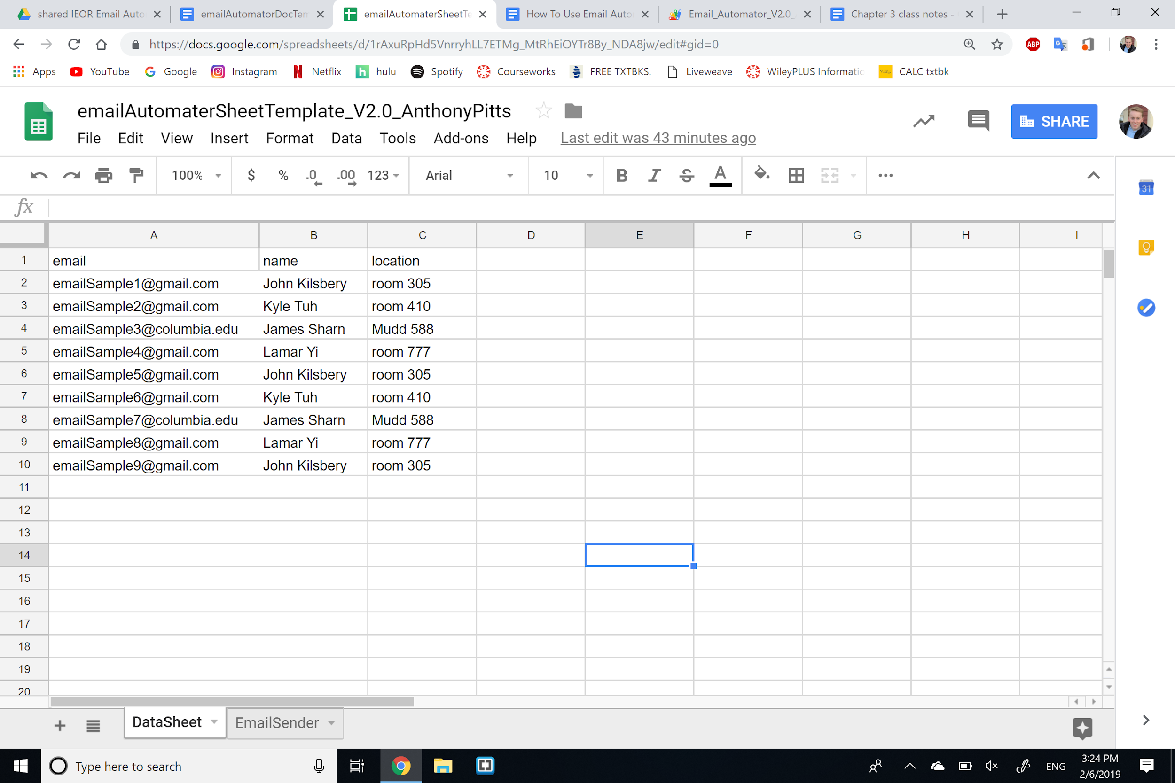
   1. Open up the [sheet template](https://docs.google.com/spreadsheets/d/1rAxuRpHd5VnrryhLL7ETMg_MtRhEiOYTr8By_NDA8jw/edit#gid=0) and make a copy of your own, so that you can edit.
   2. In your sheet, simply change the names of the columns, other than the ‘email’ column, with the unique parts of the email that you want personalized to each recipient of the email.
      1. E.g. you could make a column called “state” and under it put the state of each person, so you could reference the recipients state of residence in the email.
2. 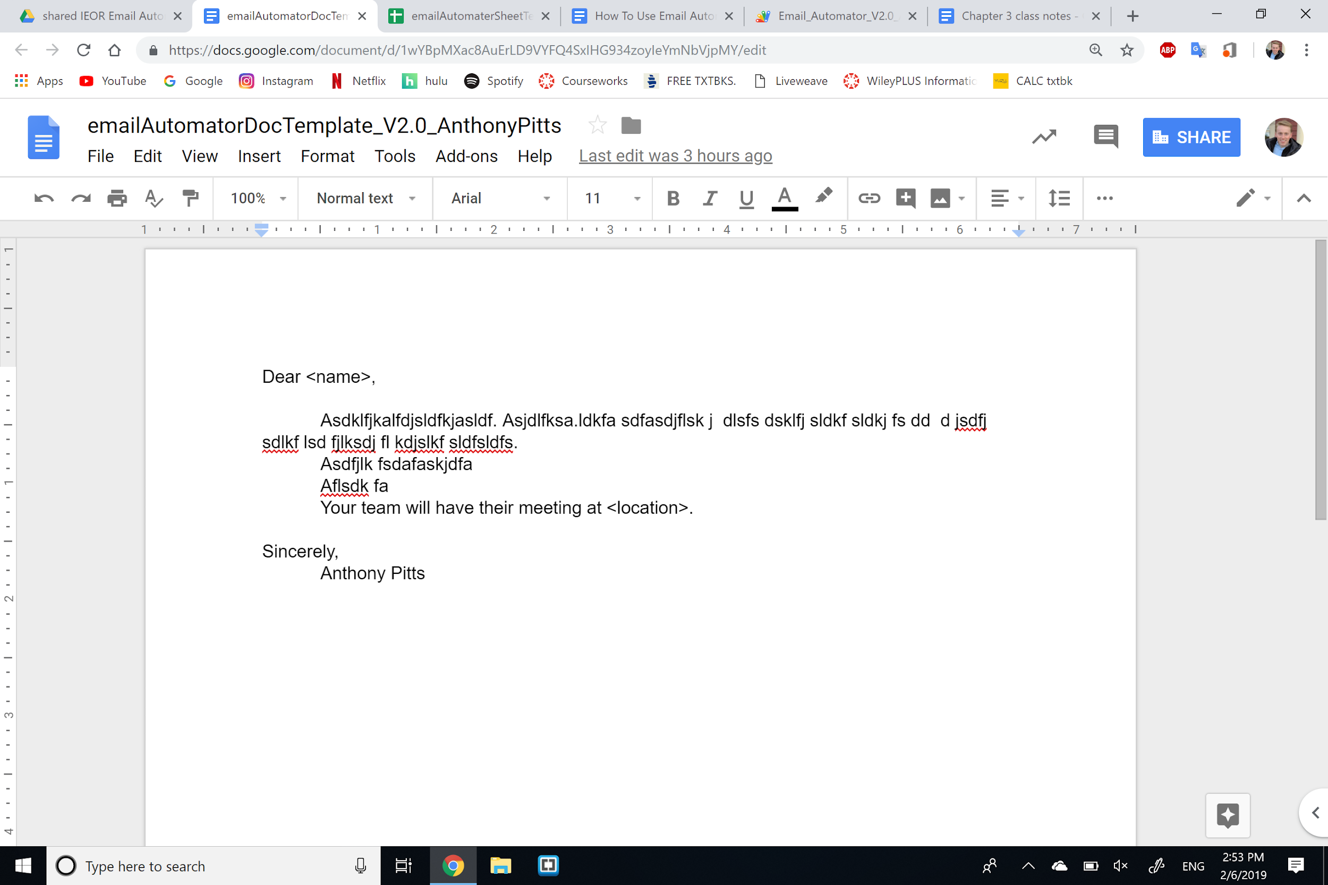
   1. Create a google doc, which will hold the body of your email.
   2. Format it as you wish, but **make sure** to place the part of the email that you wish to be personalized to each recipient inside < >. The word inside these angle brackets must match the first cell of a column of data in your spreadsheet.
3. 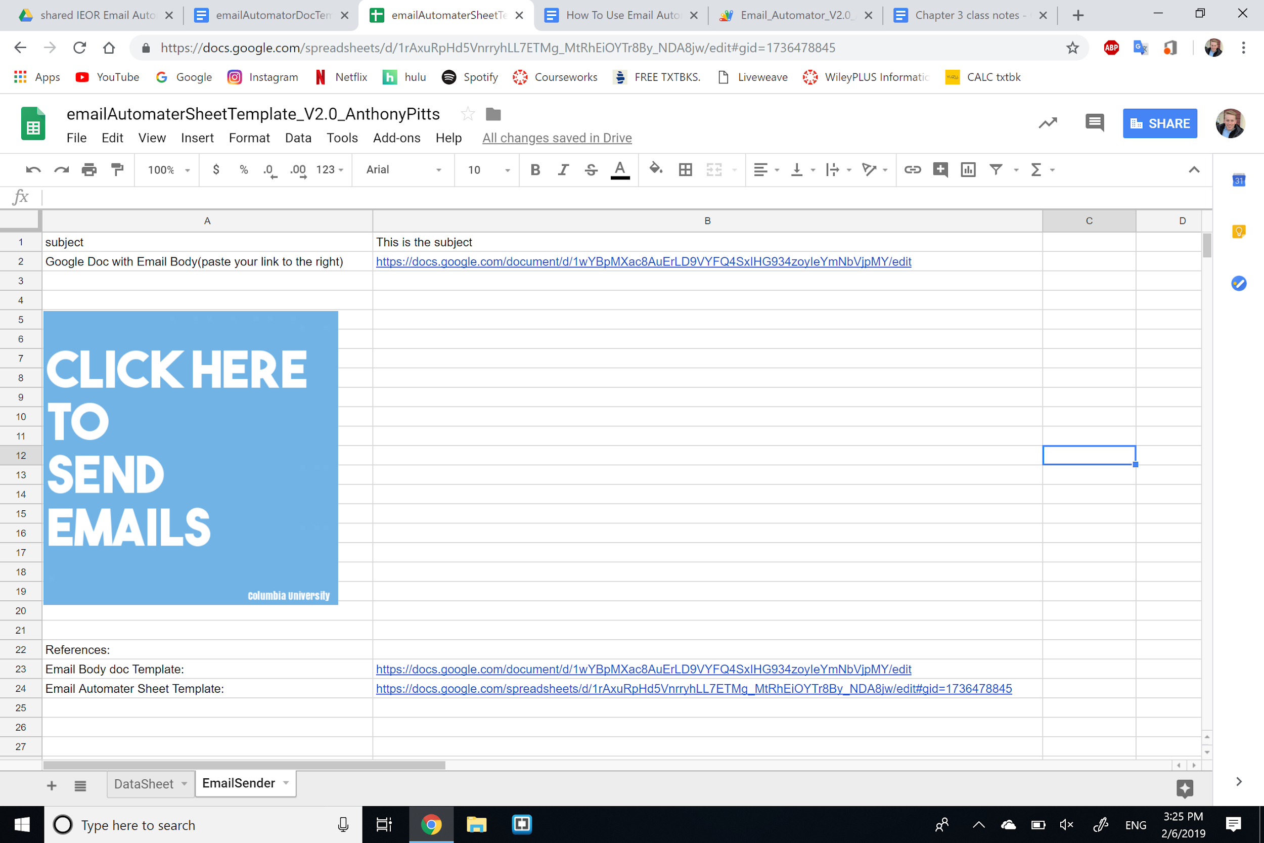
   1. In the second tab of the sheet you copied, input your subject line, link to the doc with your email body, and click on the blue ‘click here’ image. Your emails will then be sent! An example email, for the second recipient is shown below:

